UNIT II
SIGNAL GENERATION
INTRODUCTION:
The generation of signal is an important aspect of electronic troubleshooting and development. Signals are important for varieties of functions such as
- providing test conditions
- performance evaluation
- replacing missing signals
- troubleshooting
- analysis and repair
The common characteristic of all signal generators is that they provide signal with variable frequency, variable amplitude, stable and distortion less (noise free) signal. Depending on the applications, there are numerous types of signal generators available in the market which can be listed as follows
- Audio frequency generator
- Radio frequency generator
- Pulse generator
- Function generator
- Sweep generator etc.
Each generator is associated with the fixed frequency band limit which is summarised in the table below,
Band of frequency | Approximate range
Audio frequency (AF) | 20 Hz to 20 KHz
Radio frequency (RF) | Above 30 KHz
Very low frequency (VLF) | 15 Hz to 100 KHz
Low frequency (LF) | 100 Hz -500 KHz
Broadcast frequency (BF) | 0.5 Hz to 1.5 MHz
Video frequency (VF) | Dc to 5 MHz
High frequency (HF) | 1.5 MHz to 30 MHz
Very High frequency (VHF) | 30 MHz to 300 MHz
Ultra High frequency (UHF) | 300 MHz to 3000 MHz
Microwave frequency (MWF) | Beyond 300 MHz

SINE WAVE GENERATOR:
The sine wave generator represents the largest category of signal generators because of the importance of sine function in multitude of cases. This instrument covers wide range of frequencies starting from few Hertz to many Giga Hertz. Basically, a sine wave generator consists of two main blocks, An oscillator and an attenuator. The signal generators success depends on how nicely these two blocks are designed. The frequency accuracy, stability and distortion less signal depends on design of an oscillator circuit while the amplitude accuracy depends on the design of the attenuator circuit.
So the block diagram of signal generator in most basic form can be represented as

There are broad class of oscillators that use resonant characteristics of inductor (L) capacitor (C) i.e. LC circuit to generate a stable frequency. The block diagram of oscillator in its simplest form can be represented as
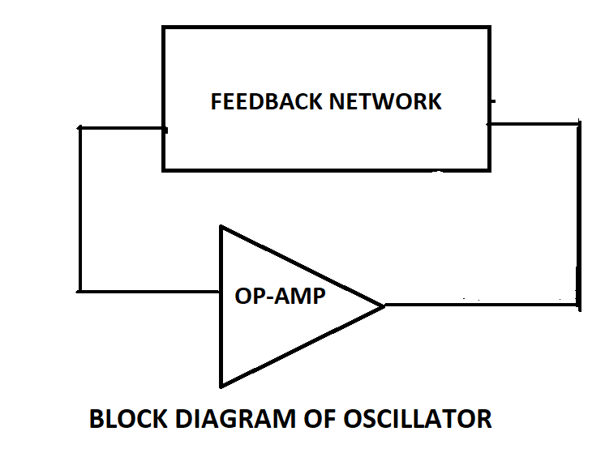
The oscillator consists of an amplifier circuit and a positive feedback network such that the total gain of this close loop i.e. gain of the amplifier divided by the loss in the feedback network is exactly equal to 1 and the total phase shift around the close loop is either 0º or 360º. These two conditions are BARCAUSHAN CRITERIAN for sustained oscillations. Sustained oscillations are those whose amplitude remains constant with respect to time.
Oscillators are designed such that these two criterion for sustained oscillation is met at only ONE frequency and this frequency is resonant frequency of the LC tuned/tank circuit. Thus resonant frequency of the tuned (LC) circuit is given by
$$f=\frac{1}{2π\sqrt{LC}} (1)$$
Where L is circuit inductance in Henry, C is circuit capacitance in Farad and f is resonant frequency in Hz.
When resonant circuit is used in the feedback network of an oscillator, the oscillator frequency is the resonant frequency of the feedback network. Figure shows actual circuit diagram of Hartley oscillator and Colpitts oscillator.
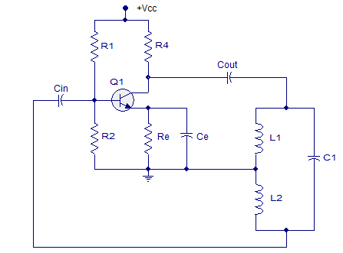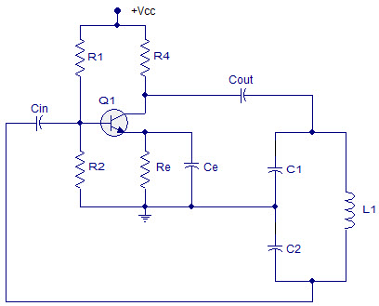
Hartley oscillator Colpitts oscillator
Hartley oscillator was invented by American engineer Ralph Hartley in 1915. The tuned circuit consists of a single capacitor in parallel with two inductors in series. The feedback signal needed for the oscillation is taken from the centre connection of the two inductors. Hartley oscillator is used to generate high radio frequency signals.
A Colpitts oscillator was invented by American engineer Edwin H. Colpitts in 1918. The tuned circuit consists of single inductor and a tapped capacitor. The feedback signal needed for the oscillation is taken from the centre connection of the two capacitors. Colpitts oscillator is used to generate low radio frequency signals.
Both the oscillator circuit uses common emitter amplifier circuit as active element of the oscillator circuit, hence it is apparent that phase shift due to amplifier is 180º regardless of the operating frequency and other 180º phase shift will be provided by the feedback resonant circuit at resonance frequency. Hence total phase shift around the loop is 360º. For an oscillator to have sustained oscillations, the gain of the active device must be reduced. This is accomplished automatically by adjusting the operating characteristics of transistor through self-bias. The amplitude of an ac voltage in the oscillator build up until the effective gain of the transistor is reduced so that the total loop gain is equal to 1.
From Eqn. 1 it is clear that both inductance and capacitance have similar control on the operating frequency of the oscillator. Hence both the elements can be used to set the frequency of the oscillator. In practice, the inductor is changed with switch (in bands) while the capacitor is changed using dial of signal generator.
ATTENUATOR:
The second part of signal generator is Attenuator. An attenuator is an electronic device that reduces the power of a signal without appreciably distorting its waveform. The function of the attenuator is to reduce the power level of the input signal. In many applications signal generator is required to supply signals of very low amplitudes for testing and evaluating radio receivers, hence attenuator is required. The attenuator reduces the power of an input signal such that the ratio of input power to output power is a constant.
The reduction in power can be expressed as the ration of log of input power to the output power by following relationship
$$A\left(dB\right)=10log\frac{(Pi)}{(Po)} (2)$$
Where A(dB) is the attenuation in decibels, Pi is input power to the attenuator and Po is output power of the attenuator.
If the signal is passed through two attenuators in cascade as shown below
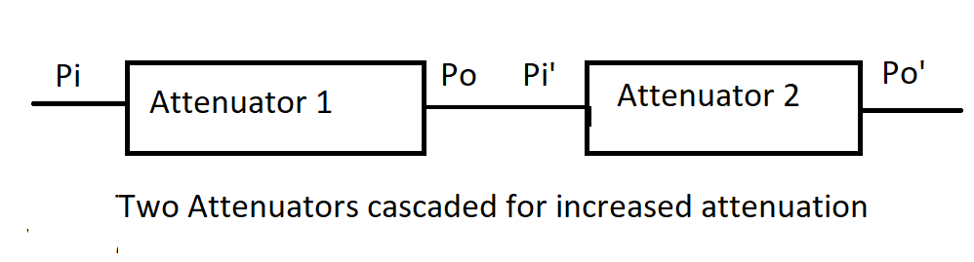
Total attenuation of $A\left(dB\right)=10 log\left(\frac{Pi}{Po}\right)\left(\frac{Pi^{'}}{Po^{'}}\right)$
$$=10log\left(\frac{Pi}{Po}\right)+10log\left(\frac{Pi^{'}}{Po^{'}}\right)$$
A(dB) = A₁ +A₂
If two attenuators are connected in series then total attenuation of the cascaded attenuators in decibel is equal to sum of attenuation of each individual attenuator.

Pi ATTENUATOR:
The word Pi attenuator has originated from Greek letter Pi and it is most versatile attenuator. Three resistors are required to construct a Pi attenuator. The Pi attenuator can be fabricated with standard components to obtain attenuation up to 20 dB for frequencies about 100 MHz.
The values of standard resistors required for the Pi attenuator having power reduction of N, where attenuation in decibel is 10logN can be calculated in following manner. Figure shows circuit diagram of Pi attenuator.
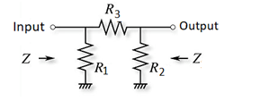
For maximum power transfer, the input resistance of all the attenuators must be equal to the system resistance Z. This is true only when the attenuator is terminated at the either end by same resistance Z.
Looking into the output with input terminated, we find the resistance R₃ is in series with parallel combination of R₂ and Z. This combination is further in parallel to R₁, which should be also equal to Z. Hence mathematically it can be expressed as
$$\frac{1}{Z}=\frac{1}{R_{1}}+\frac{1}{R_{3}+\frac{R_{2}Z}{R_{2}+Z}} 1$$
Similarly looking into the input terminals with output terminated to same resistance Z, we have R₃ in series with parallel combination of R₁ and Z. This combination is further in parallel to R_{2.} Again expressing this mathematically we can write
$$\frac{1}{Z}=\frac{1}{R_{2}}+\frac{1}{R_{3}+\frac{R_{1}Z}{R_{1}+Z}} 2$$
Because R₃ in series with either R₁ or R₂ and in parallel with Z produces same resistance Z implies that both R₁ and R₂ are same. Hence when we substitute R₁=R₂, Equations 1 and 2 reduces to one single equation.
Rewriting equation 1, with R₂ replaced by R₁ we get
$$\frac{1}{Z}=\frac{1}{R_{1}}+\frac{1}{R_{3}+\frac{R_{1}Z}{R_{1}+Z}} 3$$

$$\frac{1}{Z}=\frac{R_{3}+\frac{R_{1}Z}{R_{1}+Z}+R_{1}}{\left(R_{1}\right)\left(R_{3}+\frac{R_{1}Z}{R_{1}+Z}\right)} 4$$

$$Z=\frac{\left(R_{1}\right)\left(R_{3}+\frac{\left(R_{1}Z\right)}{R_{1}+Z}\right)}{R_{1}+R_{3}+\frac{R_{1}Z}{R_{1}+Z}} 5$$
Equation 5 has two unknowns R1 and R3 and hence cannot be solved without the aid of another equation. In order to generate another equation we consider the ratio of input voltage to output voltage $\frac{V_{1}}{V_{2}}$ written using a simple voltage divider equation as
$$V_{2}=\frac{\left(\frac{\left(R_{1}Z\right)}{R_{1}+Z}\right)}{R_{3}+\frac{R_{1}Z}{R_{1}+Z}} V_{1} 6$$
$${\frac{V_{1}}{V_{2}}}_{}=\frac{\left(R_{3}+\frac{\left(R_{1}Z\right)}{R_{1}+Z}\right)}{\frac{R_{1}Z}{R_{1}+Z}}=\sqrt{N} 7$$
There are two independent equations 5 and 7 and only two unknowns R₁ and R₃, hence can be solved using elimination method. Equation 7 can be rewritten as
$${R_{3}+\frac{R_{1}Z}{R_{1}+Z}}_{}=\sqrt{N} \frac{R_{1}Z}{R_{1}+Z} 8$$
Substituting the value of ${R_{3}+\frac{R_{1}Z}{R_{1}+Z}}_{}$in equation 5 we get
$Z=\left(\frac{R_{1}\left(\frac{\sqrt{N}R_{1}Z}{R_{1}+Z}\right)}{R_{1}+\left(\frac{\sqrt{n}R_{1}Z}{R_{1}+Z}\right)}\right) 9$
$Z=\frac{R_{1}\left(\frac{\sqrt{N}R_{1}Z}{R_{1}+Z}\right)}{\frac{R_{1}^{2}+R_{1}Z+\sqrt{N}R_{1}Z}{R_{1}+Z}} 10$
$Z=\frac{R_{1}^{2}\sqrt{N}Z}{R_{1}^{2}+R_{1}Z+\sqrt{N}R_{1}Z} 11$
Cross multiplying Eqn. 11 we get
$${ ZR}_{1}^{2}+R_{1}Z^{2}+\sqrt{N}R_{1}Z^{2}= R_{1}^{2}\sqrt{N}Z 12$$
Taking ${ZR}_{1}$common throughout we get
${ R}_{1}^{}+Z^{}+\sqrt{N}Z^{}= R_{1}^{}\sqrt{N} 13$
$R_{1}\left(1-\sqrt{N}\right)=-Z-Z\sqrt{N} 14$
${-R}_{1}\left(\sqrt{N}-1\right)=-Z\left(\sqrt{N}+1\right) 15$
$R_{1}=Z\left(\frac{\left(\sqrt{N}+1\right)}{\left(\sqrt{N}-1\right)}\right) 16$
The relationship between R₁ and R₃ is connected through Eqn. 8, hence using value of R1 in it we get expression for R₃
$R_{3}= \frac{\sqrt{N}R_{1}Z}{R_{1}+Z}-\frac{R_{1}Z}{R_{1}+Z} 17$
$R_{3}=\frac{R_{1}Z\left(\sqrt{N}-1\right)}{R_{1}+Z} 18$
Now substituting the value of R₁ from Eqn. 16, we get
$$R_{3}=\frac{z z\frac{\left(\sqrt{N}+1\right)}{\left(\sqrt{N}-1\right)} \left(\sqrt{N}-1\right)}{Z\frac{\left(\sqrt{N}+1\right)}{\left(\sqrt{N}-1\right)}+Z} 19$$
${ R}_{3}=\frac{Z^{2}\frac{\left(\sqrt{N}+1\right)\left(\sqrt{N}-1\right)}{\left(\sqrt{N}-1\right)}}{Z\left(\frac{\sqrt{N}+1+\sqrt{N}-1}{\left(\sqrt{N}-1\right)}\right)} 20$
${ R}_{3}=\frac{Z\left(N-1\right)}{2\sqrt{N}} 21$
Using Eqns. 16 and 21 the values of R₁ and R₃ can be found which gives us power reduction of log N.
PISTON TYPE ATTENUATOR:
A type of attenuator that uses no resistors at all and has been very popular for moderately priced signal generators for many years is Piston type attenuator. When carefully designed it can provide excellent accuracy.
The piston type attenuator operates on the principle of waveguide beyond cut off wavelength. When a waveguide is operated below its intended frequency, the waveguide does not effectively transmits energy and thus there is significant attenuation.
Consider the attenuator shown in the figure.
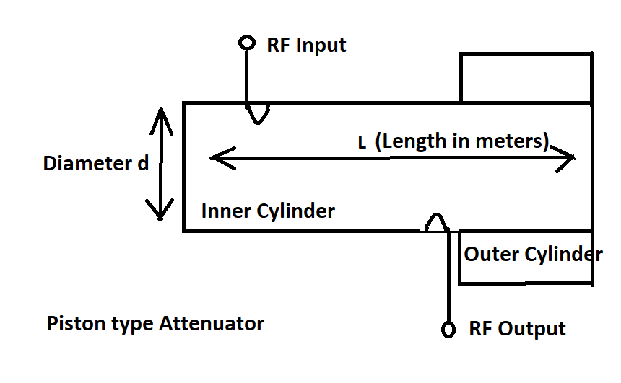
An injection loop injects energy into the inner cylinder which can be considered as section of waveguide. At the opposite end of the waveguide section, a second loop is located that is called retrieve loop or pick up look. The function of this loop is to retrieve some of the energy injected by the injection loop of the waveguide.
The attenuation is given by
$$A\left(dB\right)=32\frac{L}{d} 22$$
Where L is the distance between the two loops in meters and d is the diameter of the cylinder also in meters. According to Eqn.1 the power loss is proportional to the log distance between the two loops. It would be very convenient if the attenuation is calibrated in decibels so that form of calibration would be linear along the attenuation scale.
The linear relationship between the lengths of the separation of the loops and attenuation in decibels is only valid when a certain minimum separation is observed. When the two loops are very close to one another, other coupling mechanism comes into play other than attenuation through waveguide and results into error. The practical piston type attenuator cannot produce attenuation less than 20 dB without considerable error.
There are no resistive elements in the piston type attenuator to dissipate the power that is attenuated and the reduction in input power is accomplished by reflecting unwanted power back into the source. This implies that the input impedance of piston type attenuator is not constant and this can cause problems with certain attenuators.
To stabilize the impedance as seen by the oscillator circuit, a fixed resistive attenuator called a PAD is inserted between the piston type attenuator and the oscillator circuit. This further increases the minimum loss between the oscillator and signal generator output.
Despite of all problems associated with piston type attenuator it is regularly used particularly for signal generators for receiver testing where largest signal needed is small.
FREQUENCY SYNTHESIZED SIGNAL GENERATOR:
One very popular method of frequency synthesis is called the indirect method or the phase locked loop as shown in figure.
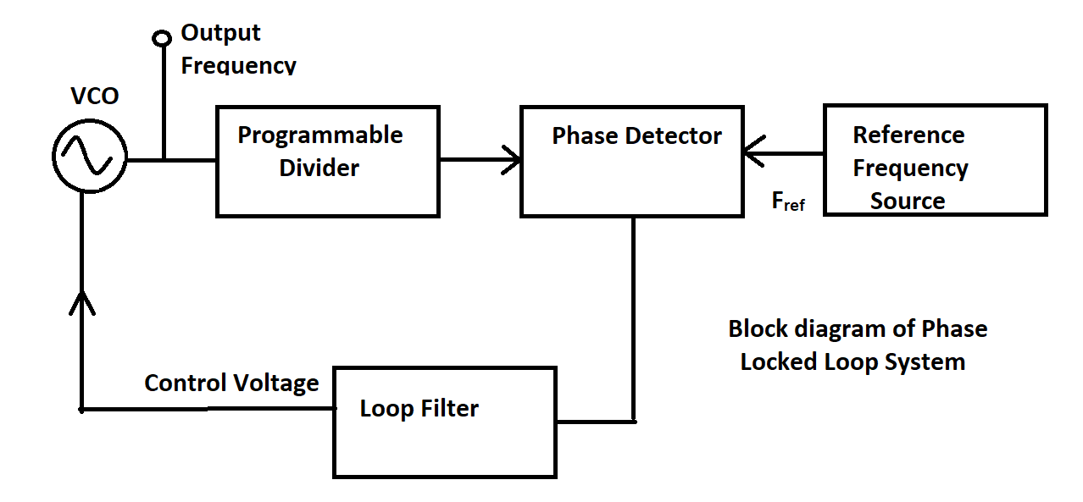
In order to construct frequency synthesized signal generator five main blocks are essential. They are Voltage control oscillator (VCO), the programmable divider, the phase detector, the reference frequency generator and the loop filter. We discuss each block individually. The voltage control oscillator is the source of output frequency and has an ability to change frequency electronically usually by applying variable dc voltage.
The programmable divider is a logic element that divides the frequency of the VCO by an integer that can be entered via programmable switches generally a micro-processor.
The phase detector provides an analog output that is a function of the phase angle between the two inputs. In present case the two inputs are from reference frequency source and programmable divider. The phase difference between these two signals are detected by this block.
The reference source is a very accurate and stable frequency source which is typically a quartz crystal oscillator. The accuracy of the entire synthesizer is dependent on the accuracy of this block. The crystal oscillator operates in the region from 1 to 10 MHz and any smaller frequency is obtained by dividing its frequency by digital counter.
The loop filter is an analog filter and is required to assure stable and noise free operation of the frequency synthesizer. Now we try to understand how this five blocks work in cohesion.
Assume that the VCO is electronically tuned to multiple of the reference frequency. If an integer is entered into the programmable divider we obtain
$$f_{V}=Nf_{r } 23$$
Where f_{V} is the desired frequency of VCO and N is the integer entered into the programmable divider and f_{r} is the reference frequency applied to the phase detector. As the programmable divider, divides the frequency of the VCO by N, the output frequency of the programmable divider is f_{v}/N i.e. f_{r.}
The output of the programmable divider is fed to the phase detector and compared to the phase of the reference frequency. If the output of the phase detector were returned to the VCO any variation in the phase could be corrected so that the frequency of the VCO would be exactly N times the reference frequency. However, the phase determination can be made only once each reference frequency period and the frequency of the VCO can be corrected at this rate.
A filter is inserted between the phase detector and the VCO so that the periodic frequency changes are smoothened and the frequency modulation is reduced.
The major disadvantage of phase lock loop system is that the loop filter cannot filter all the sidebands and this causes great deal of frequency modulation which is not desired. The other disadvantage is that loop filter also affects the frequency slewing characteristics of the synthesizer.
Function Generator:
A function generator is a versatile instrument designed to deliver different type of waveforms whose frequencies are adjustable over a wide range. The most common types of waveforms are Sine wave, Triangular wave, Square wave and Saw-tooth wave. The frequencies of these waveforms may be adjusted from a fraction of Hertz to several hundred Kilohertz. The various outputs of the generator may be available simultaneously. For instance, square wave may be used for linearity measurement in an audio system, a saw tooth may be used to drive the horizontal deflection amplifier of cathode ray oscilloscope, providing visual display of the measurement results.
The generator has a capability of providing output waveforms (Sine, Triangular, Sawtooth, Square) at very low frequencies. Since the low frequency is limited using LC or RC circuits, a different approach is employed in function generator. The frequency of the waveform is varied using frequency control network governed by frequency dial on the front panel of the instrument or alternatively by an externally applied control voltage that drives the integrator circuit. This function generator delivers all required waveforms from very low frequency of 0.01 Hz to 100 KHz.
The frequency control voltage regulates the two current sources namely upper current source and lower current source. The upper current source supplies constant current to the integrator whose output voltage increases linearly with time.

Function Generator Block Diagram
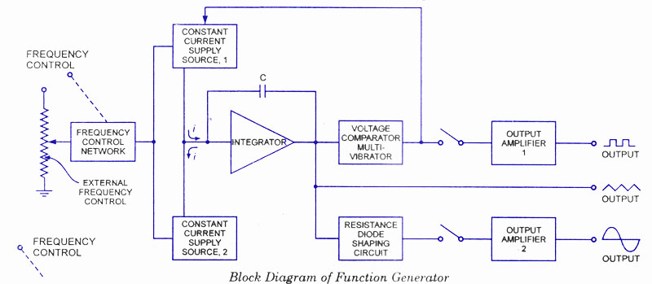

The output voltage from an integrator is given by
$V_{out}=-\frac{1}{C}\int{idt}$ 24
An increase or decrease in the supplied current in turn increases or decreases the slope of the output voltage and thus controls the frequency.
The voltage comparator multivibrator changes state at the predetermined maximum level of the integrator output voltage. This will automatically cut-off the upper current supply and simultaneously switches ON the lower current source. The lower current source supplies reverse current to the integrator as a result its output drops linearly with time and again when it reaches the lower predetermined level, the voltage comparator automatically switches to Upper current source. Thus at the output of comparator we get square wave and at the output of the integrator we get triangular waveform. The frequency of both the waveforms is the same. Further, to change the triangular waveform to sinusoidal wave, a resistance diode network is used which changes slope of the triangular wave with its amplitude change with less than 1% distortion.

Multiple Choice Questions:
- The frequency band limits for Audio Frequency band is
- 1.5 Hz to 100 KHz
- 20 Hz to 20 KHz
- 100 KHz to 500 KHz
- 500 KHz to 1KHz
- The frequency band limits for radio Frequency band is
- Above 30 KHz
- 20 Hz to 20 KHz
- 100 KHz to 500 KHz
- The frequency band limits for Broadcast band is
- 1.5 Hz to 100 KHz
- 0.5 Hz Hz to 1.5 MHz
- 100 KHz to 500 KHz
- The resonant frequency for an LC tunes circuit is given by
$\left(i\right) f=\frac{1}{2π\sqrt{LC}}$
$\left(ii\right) f=\frac{1}{4π\sqrt{LC}}$
$\left(iii\right) f=\frac{2}{2π\sqrt{LC}}$
(iv) None of the above

- In case of Hartley oscillator, tapped _________is used.
- Capacitor
- Inductor
- Both capacitor and inductor
- In case of Colpitts oscillator, tapped _________is used.
- Capacitor
- Inductor
- Both capacitor and inductor
- The unit for attenuation is
- Decibels
- Volts
- Ampere
- If two attenuators are connected in cascade then total attenuation is given as
- Subtraction of individual attenuator
- Addition of individual attenuator
- Product of individual attenuator
- In case of Piston attenuator the attenuation in dB is given by
- $A\left(db\right)=32\frac{l}{d}$
- $A\left(db\right)=32\frac{d}{l}$
- $A\left(db\right)=23\frac{l}{d}$
- In frequency synthesized signal generator, --------------------is used as reference frequency source.
- Phase shift oscillator
- Wein bridge oscillator
- Quartz crystal oscillator
- The voltage at the output of the integrator circuit has
- Square waveform
- Triangular waveform
- Sinusoidal waveform
- An integrator circuit has -------------------- in the feedback network.
- Diode
- Inductor
- Capacitor
- The output of a comparator circuit is a
- Square waveform
- Triangular waveform
(iii) Sinusoidal waveform
Q.2 : Short Questions:
1. What are the important blocks of signal generator? What are their
functions?
2. The frequency accuracy depends on design of which block of signal
generator?`
3. The amplitude accuracy depends on design of which block of signal
generator?
4. Define Attenuator.
5. What will be overall attenuation if two attenuators are connected in
cascade?
6. What is function of PAD in piston type attenuator?
7. Which types of waveforms are generated in piston type attenuator?
8. Which types of waveforms are generated by integrator?
9. Which types of waveforms are generated by Comparator?

Q. 3. Long Questions:
1. Write a short note on sine wave generation.
2. Derive an expression for resistors R₁, R₂ and R₃ in Pi attenuator if the decibel
attenuation is 10 log N.
3. Describe in detail working of Phase locked loop system.
4. Explain in detail working of function generator.

