FYBSc Semester 1 English
Topic 2
Describing A Picture
Introduction:
It is necessary for students to learn how to use English for describing places, people and objects, etc. They have to equip themselves with the knowledge and use of English structures and vocabulary to be able to meet the requirement of the job market, after their graduation. They may take up a job of a salesman, tourist guide, or they may even like to take up journalism as their career. Whatever field they choose, they will need English for their efficient functioning in that field. This unit and the following ones also have been written with this objective in mind.

Do:
- Look at your picture carefully and take a few moments to think before you start talking.
- Talk for all the time you are given. If you have one minute to do the task, use every second.
- Practise the useful language below so you can explain which part of the picture you are talking about.

Don’t:
- Panic if you don’t know the words for all the things in the picture. You don’t need to know all the words for everything in the picture if you know what to say when you don't know an exact word.
- Get distracted and start talking about something else. Focus on the photo or picture.
- Panic if your mind goes blank. Take a deep breath, look at the picture and start again.
If you are asked to describe a photo or a picture in the exam, here is some language you can use
Example:
This is a kitchen platform. Above it, there is a small cupboard in which there are kettle and pans. On the platform, there is a gas-stove as well as a microwave unit. Near the microwave, there is a sink with water-taps. Below the kitchen platform, there are a number of cupboards to keep big and small dishes, pots, etc.
2 There is also a waste-bin at the right hand side of the platform.
Note the structure again:
This is ----,
There is -----,
There are -----.
Note also a number of prepositional phrases used here to state the place or location of things:
above the platform, on the platform, near the microwave, below the kitchen platform, etc.
Before you describe any picture, look at it carefully and answer these questions:
1) Where do you think this is?
2) Who do you think the people are?
3) What are the people doing? Use Present continuous Tense.

What is in the picture?
In the picture I can see ...
There’s / There are ...
There isn’t a ... / There aren’t any ...

Say what is happening with the present continuous
The man is ...ing
The people are ...ing
It’s raining.

What is where in the picture?
At the top/bottom of the picture ...
In the middle of the picture ...
On the left/right of the picture ...
next to
in front of
behind
near
on top of
under

If something isn’t clear
It looks like a ...
It might be a ...
He could be ...ing
Maybe it’s a ...
:

What I think about the picture
- It seems as if ...
- The person/man/boy/ woman/ girl seems to ...
- Maybe ...
- I think ...
- ... might be a symbol of ...
- The atmosphere is peaceful/depressing ...
- I (don't) like the picture because ...
- It makes me think of ...

1. Introduction
- The photo/picture shows ...
- It was taken by/in ...
- It's a black-and-white/coloured photo.

2. What is where?
- In the foreground/background you can see ...
- In the foreground/background there is ...
- In the middle/centre there are ...
- At the top/At the bottom there is ...
- On the left/right there are ...
- Behind/In front of ... you can see ...
- Between ... there is ...

3. Who is doing what?
Here you describe the persons in the picture or you say what is happening just now. Use the Present Progressive.

4. What I think about the picture
- It seems as if ...
- The person/man/boy/ woman/ girl seems to ...
- Maybe ...
- I think ...
- ... might be a symbol of ...
- The atmosphere is peaceful/depressing ...
- I (don't) like the picture because ...
- It makes me think of ...

Describe the following objects by shape, colour and material.
 | shape | colour | material
briefcase | rectangular | black | leather
Coca-Cola bottle | cylindrical | brown | glass
iPhone | flat  rectangular | grey | metal,  glass
pencil | cylindrical | yellow | wood
envelope | flat  square | white | paper
DVD | flat  round | silver | plastic

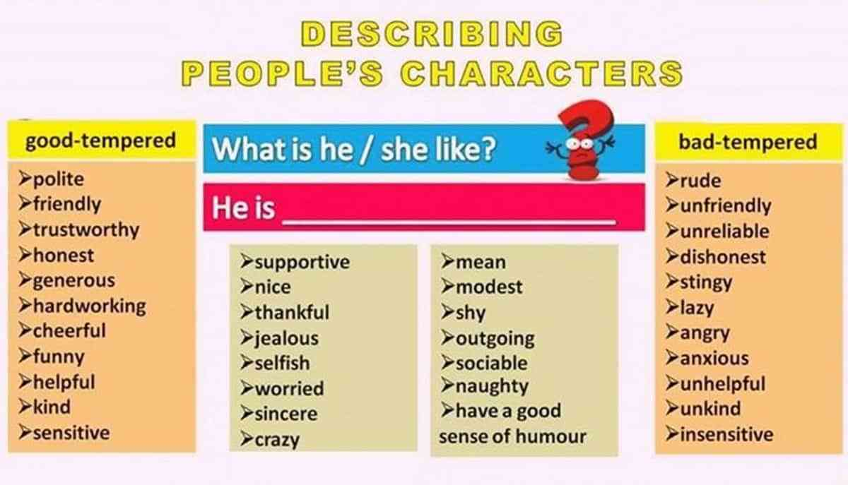
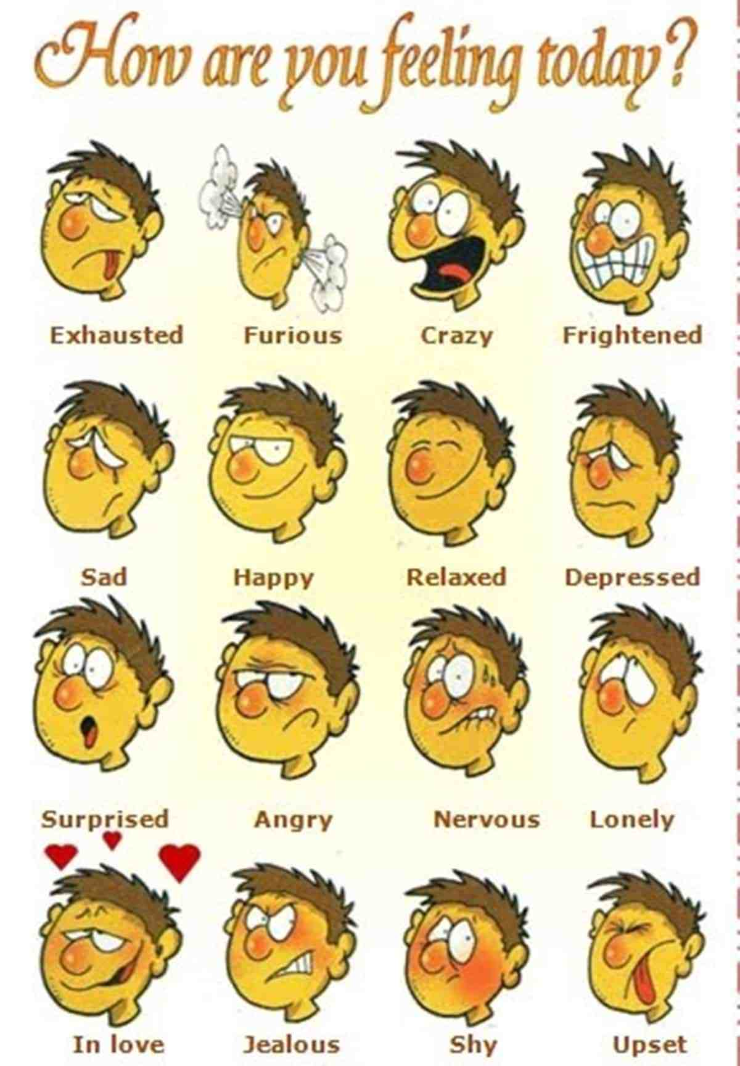
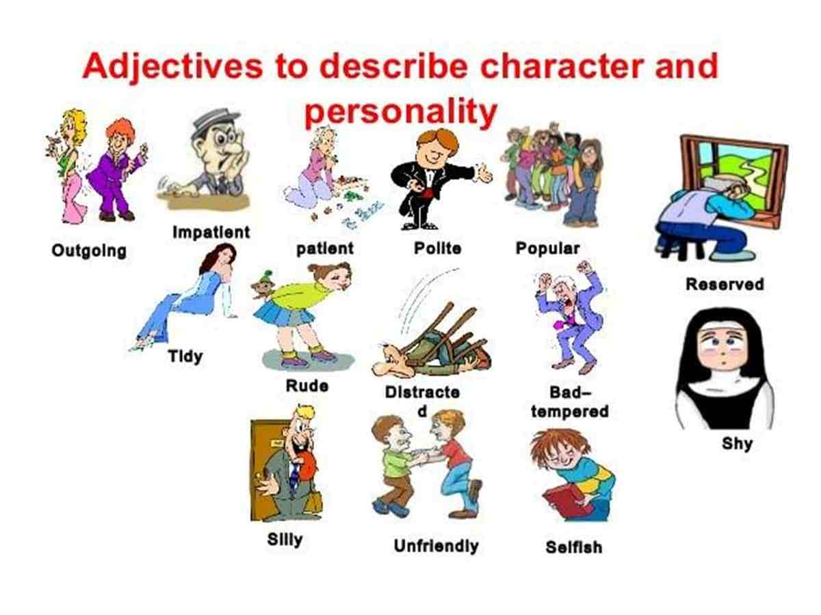1. Describe where things are in the picture

Make sure you are familiar with the language used to describe where something is in a picture. Check that you know how to use the phrases in the boxes below:

IN THE TOP AT THE TOP IN THE TOP LEFT (-HAND) RIGHT (-HAND) CORNER CORNER ON THE LEFT (-HAND) IN ON THE RIGHT (-HAND) SIDE THE SIDE MIDDLE IN THE BOTTOM IN THE BOTTOM LEFT (-HAND) RIGHT (-HAND) CORNER AT THE BOTTOM CORNER IN THE BACKGROUND FOREGROUND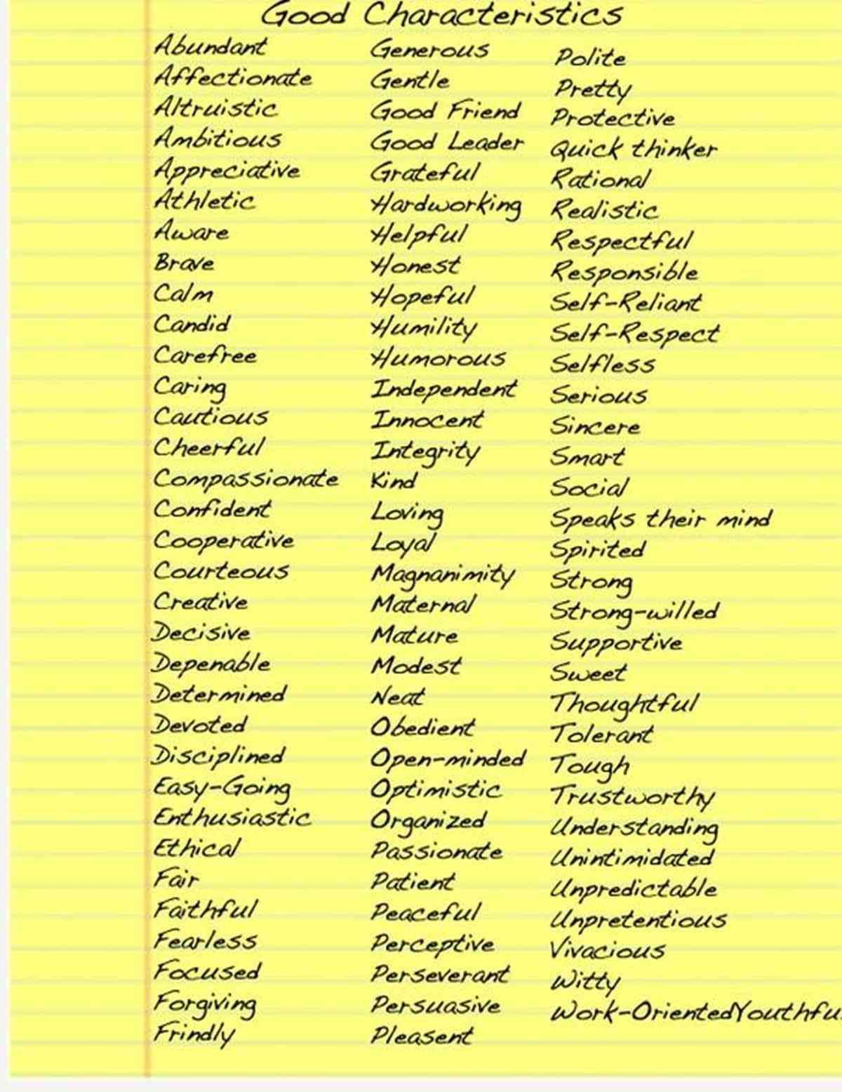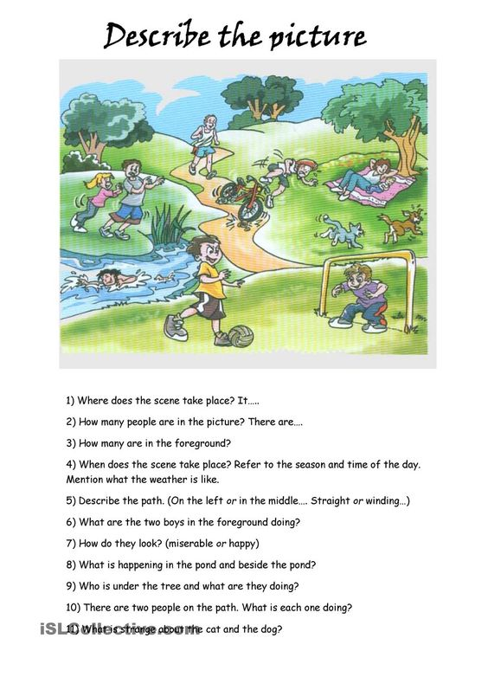Words that Embrace a Place
The words we choose will allow the reader to understand the writer's perspective. To call something bustling and vibrant is quite different from desolate and deserted. Will any of these descriptive words for places stoke the flames of your next scene?
- Alive - Full of life
- Attractive - Pleasing; charming
- Beautiful - Having qualities that are pleasing or appealing
- Bustling - Full of life, energy
- Calm - Peaceful; free from stress
- Charming - Fascinating; likeable
- Cosmopolitan - Appealing to people from all across the globe
- Enchanting - Delightful; fascinating
- Fascinating - Alluring; captivating
- Fresh - Something newly made and full of vigor
- Homey - Cozy; inviting
- Inspiring - Enlivening; motivating
- Lively - Full of life and spirit
- Peaceful - Calm; friendly
- Picturesque - Scenic; beautiful
- Unspoiled - Untouched by man; pure
- Vibrant - Full of life; energy

Words to Express Dislike for a Place
If the show doesn't fit, don't force it. Go ahead and call it polluted, rundown, or even horrifying. Try to evoke scents as well as sights with your prose. Some of these words may be subject to opinion, such as crowded or touristy, but readers will quickly catch your connotation.
- Bleak - Gloomy; somber
- Boring - Dull; uninteresting
- Creepy - Causing feelings of fear or disgust
- Crowded - Filled to capacity
- Deserted - Abandoned; uninhabited
- Desolate - Empty; bleak
- Dull - Boring; lacking zest
- Expensive - Costly; having a very high price
- Horrifying - Frightening; disgusting
- Nightmarish - Resembling a bad dream
- Polluted - Dirty; contaminated
- Rundown - In poor condition
- Stormy - Turbulent; tempestuous
- Touristy - Of or for tourists, suggesting tastelessness
- Ugly - Visually unpleasing

More Words to Describe a Place
Sometimes, it all boils down to the facts of the matter. Perhaps you're visiting ancient ruins or staying at a contemporary resort. Here are some unbiased descriptors to help you label a place:
- Ancient - Belonging to an earlier period of time
- Contemporary - Existing in the present time
- Magical - Captivating; enchanting
- Majestic - Grand; impressive; stately
- Modern - Of or relating to the current time
- Mystical - Magical; enigmatic
- Quiet - Not noisy
- Traditional - In keeping with conventional customs
